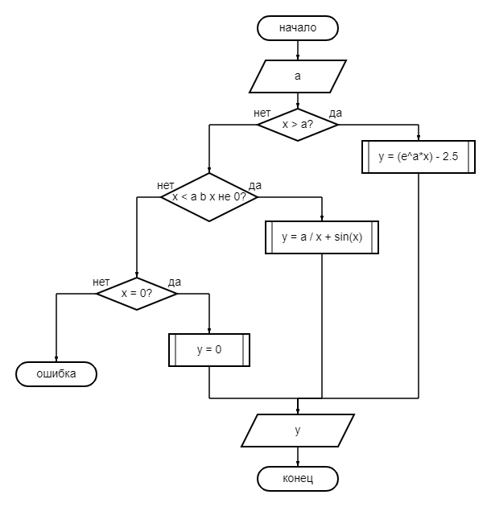
y = (e ^ (a * x)) – 2.5
x > a
|a| <= DBL_MIN
и

